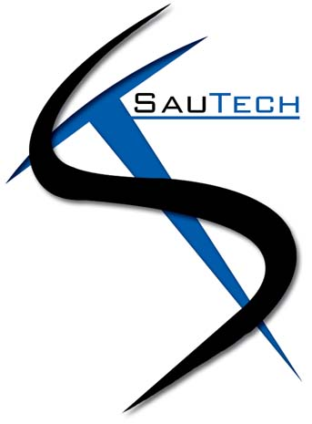

PROPOSAL DOCUMENT

Vulnerability Assessment &
Penetration Testing (VAPT) Report

Cloud Solve

18 October 2023
© Sautech (Pty) Ltd. http://www.sautech.net

TABLE OF CONTENTS

1 Executive summary 2
2 scope of testing 3
3 Methodologies used 3
3.1 Nmap / Zenmap 3
3.2 Nessus 3
3.3 Greenbone Enterprise 3
Greenbone is the world’s most widely used vulnerability management provider. 3
4 Stay One Step Ahead of Attackers 4
4.1 BRUTE FORCE 4
4.2 Applications used in Brute Force Include: 5
5 Infrastucture 5
5.1 Afrihost Server – 197.242.150.118 5
6 Reporting Conclusion 7
7 Auditors 7

Executive summary

The purpose of this assessment was to point out security loopholes, business logic errors, and missing best security practices. The tests were carried out assuming the identity of an attacker or a malicious user but, no harm was made to the functionality or working of the application / network. A full scan was also performed on the infrastructure to demonstrate a known attack, i.e. someone on the internal network or same public subnetted infrastructure. The scans and brute force were performed over 5 (Five) business days, as full and slow comprehensive audits were performed. These types of scans also look at unknown connectivity options, including packet SYN requests.

The overall results will be published below, some recommendations however, is offered and also mentioned throughout this document.

scope of testing

Security assessments include testing for security loopholes in the scope defined below. Apart from the following, no other information was provided. Nothing was assumed at the start of the security assessment. The following scope of servers were covered under the security audit:

- Server hosted at Afrihost – 197.242.150.118

Methodologies used

Sautech performed various audit techniques that includes the following:

Nmap / Zenmap

Nmap, short for Network Mapper, is a free and open source tool used for vulnerability checking, port scanning and, of course, network mapping. Despite being created back in 1997, Nmap remains the gold standard against which all other similar tools either commercial or open source, are judged.

To deploy Nmap, users originally had to have some advanced programming skills, with the introduction of the Zenmap tool for Nmap, which adds a graphical interface that makes launching the program and analysing the returned output it generates much more accessible.

Nessus

Nessus is a remote security scanning tool, which scans a computer and raises an alert if it discovers any vulnerabilities that malicious hackers could use to gain access to any computer you have connected to a network. It does this by running over 1200 checks on a given computer, testing to see if any of these attacks could be used to break into the computer or otherwise harm it.

Greenbone Enterprise

Greenbone is the world’s most widely used vulnerability management provider.

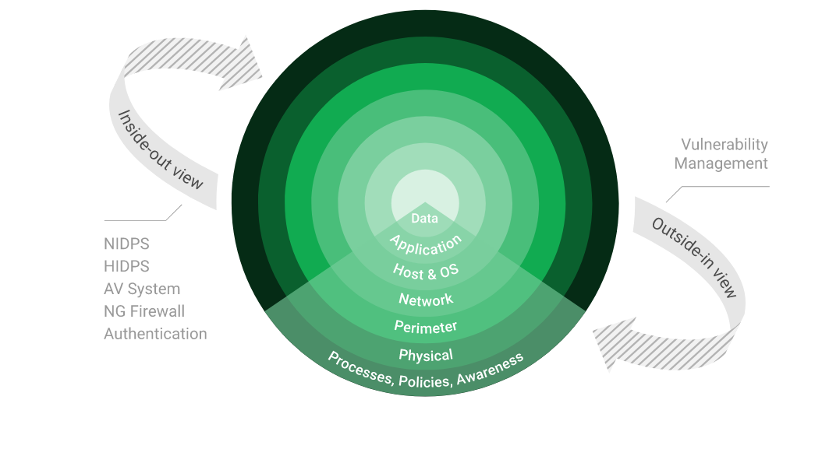

Stay One Step Ahead of Attackers

IT security is a process – Open Source vulnerability management provides the foundation. Once you know where the chinks are in your armor, you can do something about them.

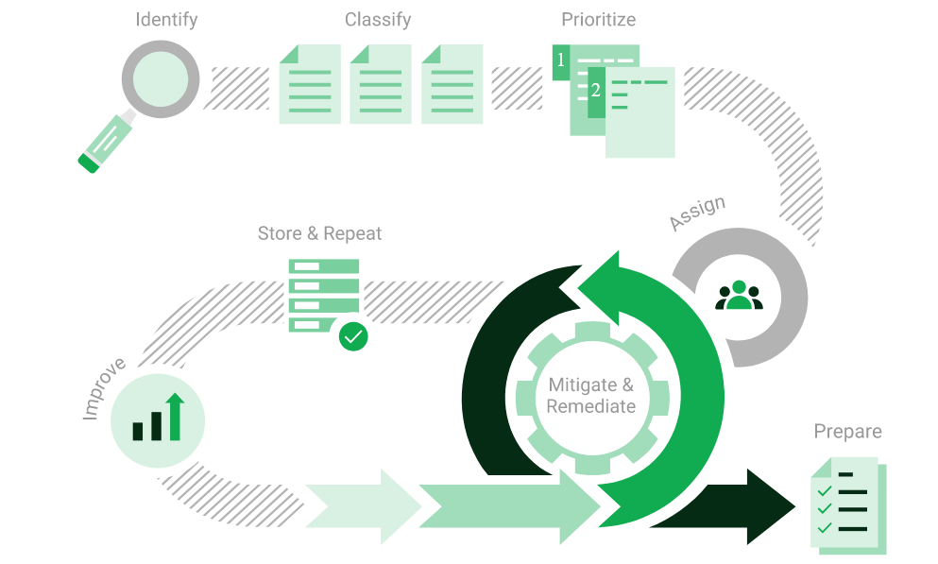

The process – from recognition to remedy and monitoring – represents a continuous cycle. You’ll always be one step ahead of attackers.

BRUTE FORCE

- A brute force attack is a hacking method that uses trial and error to crack passwords, login credentials, and encryption keys. It is a simple yet reliable tactic for gaining unauthorized access to individual accounts and organizations’ systems and networks. The hacker tries multiple usernames and passwords, often using a computer to test a wide range of combinations, until they find the correct login information.

- The name "brute force" comes from attackers using excessively forceful attempts to gain access to user accounts. Despite being an old cyberattack method, brute force attacks are tried and tested and remain a popular tactic with hackers

Applications used in Brute Force Include:

Hydra is a parallelized network login cracker built in various operating systems like Kali Linux, Parrot and other major penetration testing environments. Hydra works by using different approaches to perform brute-force attacks in order to guess the right username and password combination. Hydra is commonly used by penetration testers together with a set of programmes like crunch,[2] cupp[3] etc, which are used to generate wordlists. Hydra is then used to test the attacks using the wordlists that these programmes created.

Over 1 Million + Username and password combos are used to Brute force application like RDP, SSH etc.

Infrastucture

Afrihost Server – 197.242.150.118

We have performed three types of scans / attacks on the production server namely:

- Port Mapping (Open / Exposed Services) These were performed from unknown and known locations to test not just the security from the perimeter, but also include local network. Based on the port mapping open access to Public and Private, selected coordinated assessments were performed specific to the open connectivity received.
- Vulnerability Assessments.

Port Mapping

Nmap can be used by hackers to gain access to uncontrolled ports on a system. All a hacker would need to do to successfully get into a targeted system would be to run Nmap on that system, look for vulnerabilities, and figure out how to exploit them.

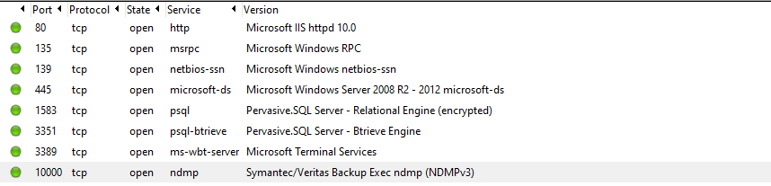

Vulnerability Assessment

Multiple technologies were used to perform a vulnerability assessment, below is the summarised version of the relevant results:

We have attached the below “highlight” in a separate report so that you can click on the “Plugin” link to get the resolution.

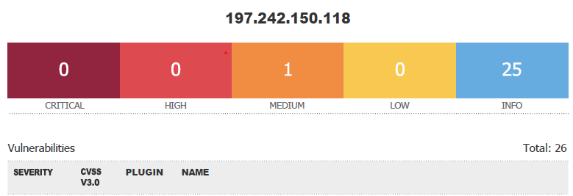

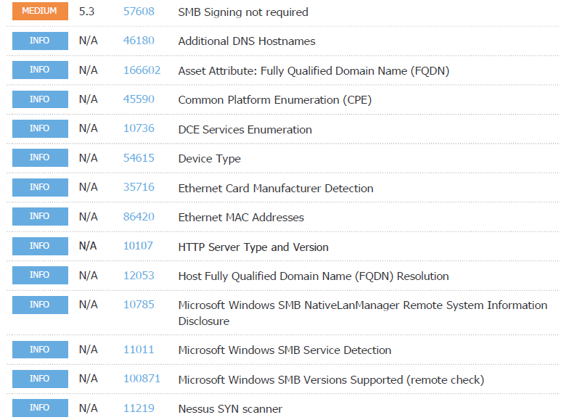
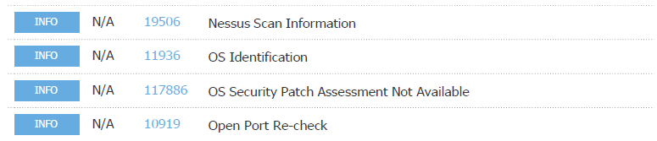
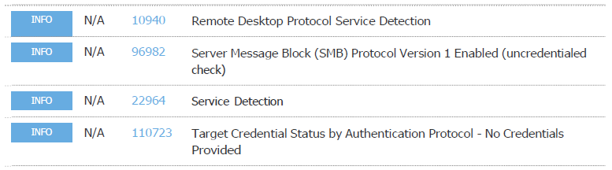

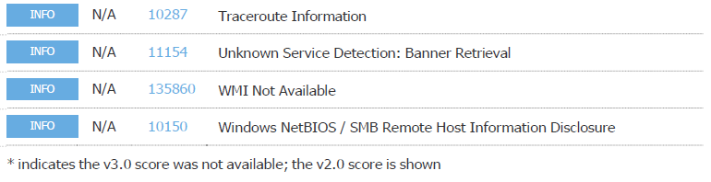

Reporting Conclusion

It is our view from External Testing where the SMB port is open to public, ports needs to be closed down.

The HTTPS updates as these are open to the public, low and medium risk, should be tested and implemented as soon as possible.

Two addendum reports are attached to this report and should be read as one document.

With the following test performed:

- Vulnerability assessment on CVE
- Penetration testing on login ports i.e.: smb open

Auditors

These audits were concluded over a period of 5 days.
We hereby confirm that the above information is true and correct:

18th October 2023 – Krugersdorp, South Africa

_________________________ _________________________
Riaan van Jaarsveld Lukas Janse van Rensburg
Security Expert – CCSA Security Engineer

